**Experiment # 03**

**LED Running Lights with Light and Sound sensor**

Section: **BSCpE 3-1**

Group Number: **#5**

Members:

**CASAMORIN, Jay**

**CHIU, John Kristian**

**MEDIAVILLIO, Carl Lewis**

Procedure:

1. Merge experiment 01 and Experiment 02, removing the LCD from experiment 02.
2. Now, with sensors attached in the Arduino board. We can have a display output using our LED array.
3. Using the data from the sensors gathered in experiment 02, run a pattern of running lights for every level of loudness in sound sensor and brightness in light sensor.

Source Code:

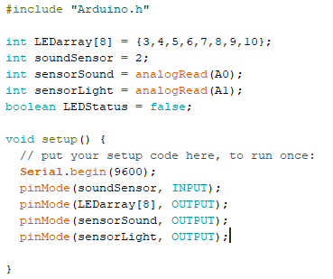

Circuit Diagram:

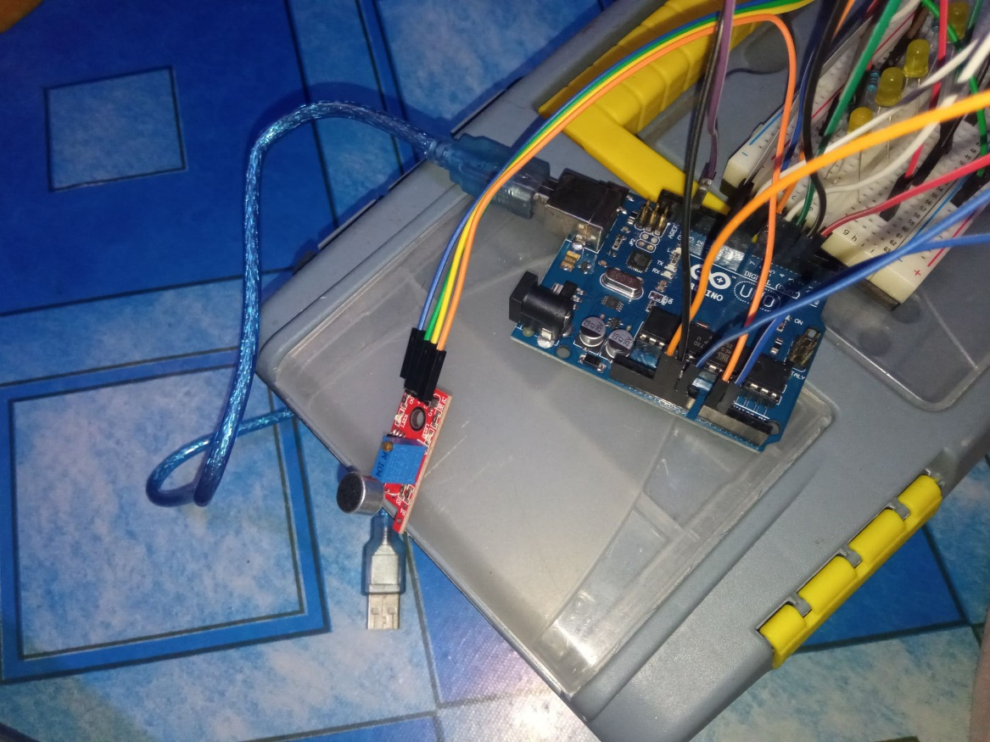

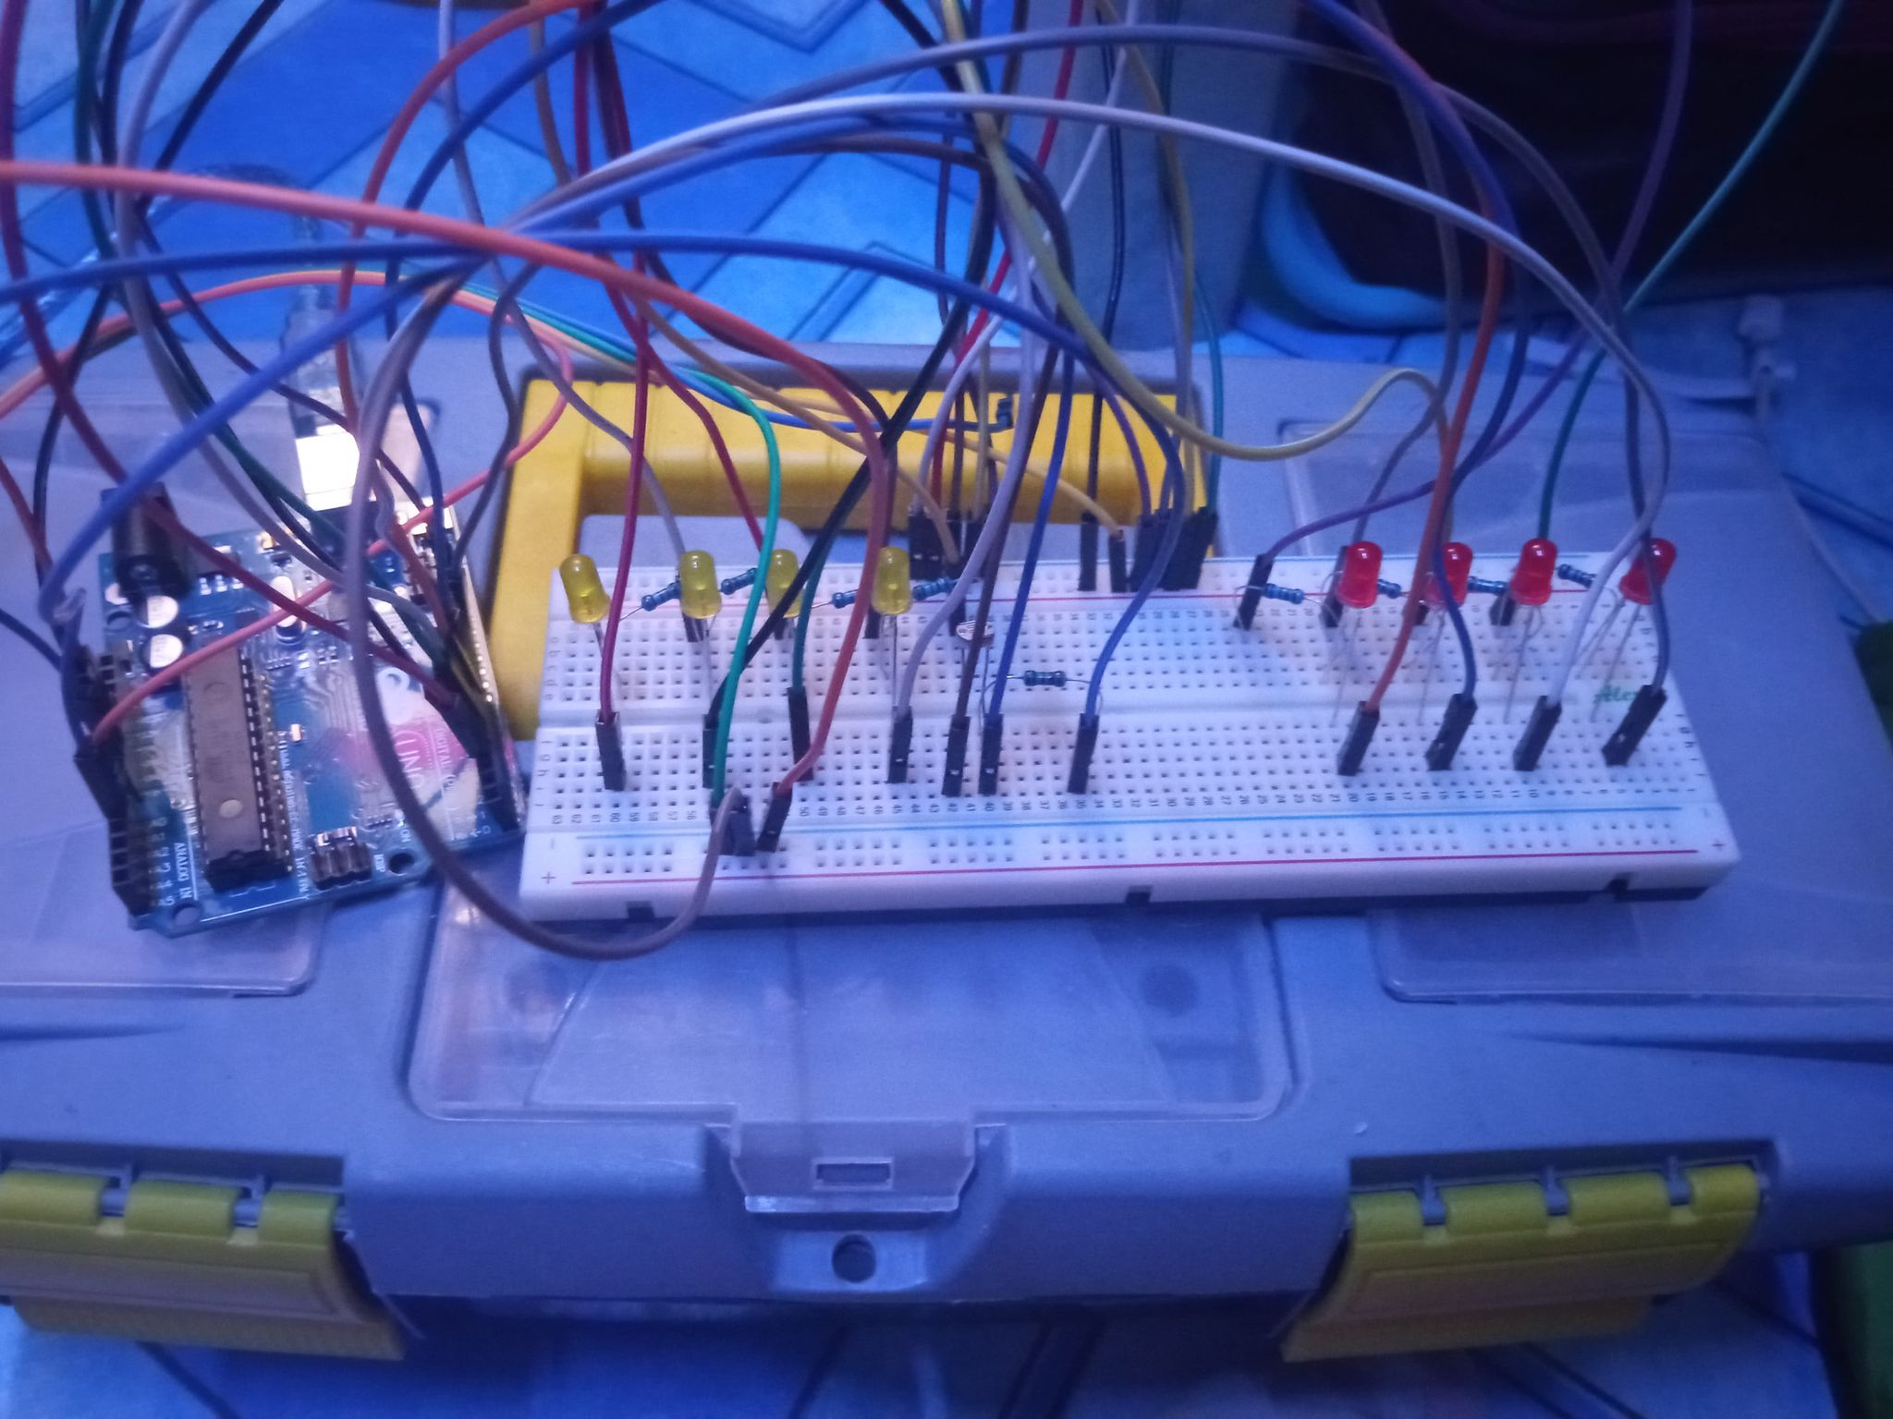

Observations: